Create project like the following figure:

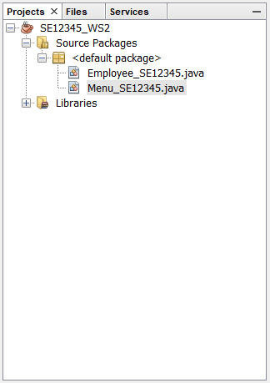

1. Design the GUI like the following figure**(5 marks)**

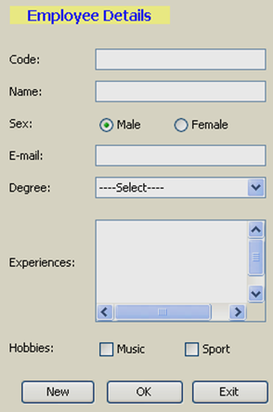

1. Design the GUI like the following figure**(5 marks)**

